**Design Phase And Testing Phase Document : Credit Card Processing**

**DOCUMENTATION OF USE CASE DIAGRAM**

* Actors in the use case diagram are Customer,Banker and Retailer.
* The use cases are creating account**,**credit card request,issue card,bank enquiry,paying bill,preparing bills,purchasing items.
* The actor use the use case are denoted by arrow.
* The creating account use case creates the account for the user by taking details like name,password,address,mobile number.
* The customer requests for credit card by providing details like name and account number.
* Once the customer submits his request the bank will enqire his details.
* The bank will issue the credit card only if all the customer credentials are valid.
* The customer will purchase any item from the retailer and the retailer will prepare the bill and verify the credit card details with the bank.
* The payment for purchasing item is successful.

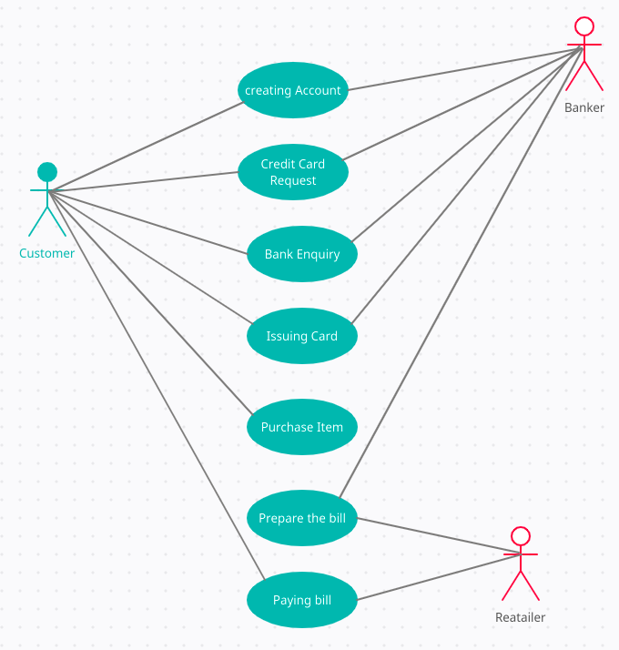

**DOCUMENTATION OF CLASS DIAGRAM**

**BANKER**

* The banker have attributes like banker id,banker name,banker branch.
* The banker has to credit the payment from the customers account and verify the customers account and update the customers account up to date and also issue the credit card whenever necessary.

**CUSTOMER**

* Customer have attributes like customer id,customer name,customer data,customer number,customer account number,customer address,credit card number and email id.
* The customer will be purchasing the items from the retailer and makes the bill payment.

**RETAILER**

* Retailer have attributes like id,address,shop name,phone number and email id.
* The retailer will be validating the credit card and bill the payment.

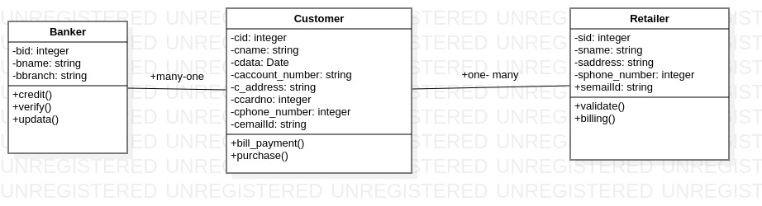

**DOCUMENTATION OF SEQUENCE DIAGRAM**

* The customer selects the bank and create an account
* The customer request bank to issue a credit card
* The bank will enquire the customer details and bank will issue the card only if all the credentials are valid.
* The customer will be purchasing the item from any shop and the item will be sent for billing
* The retailer then prepare the bill for the selected item. Based on the bill the customer will be swiping the credit card.
* The retailer will be validating the card with the bank account , if the card is valid the payment would be successful.
* The money will be deducted from the customers account and the customer will check the transactions.

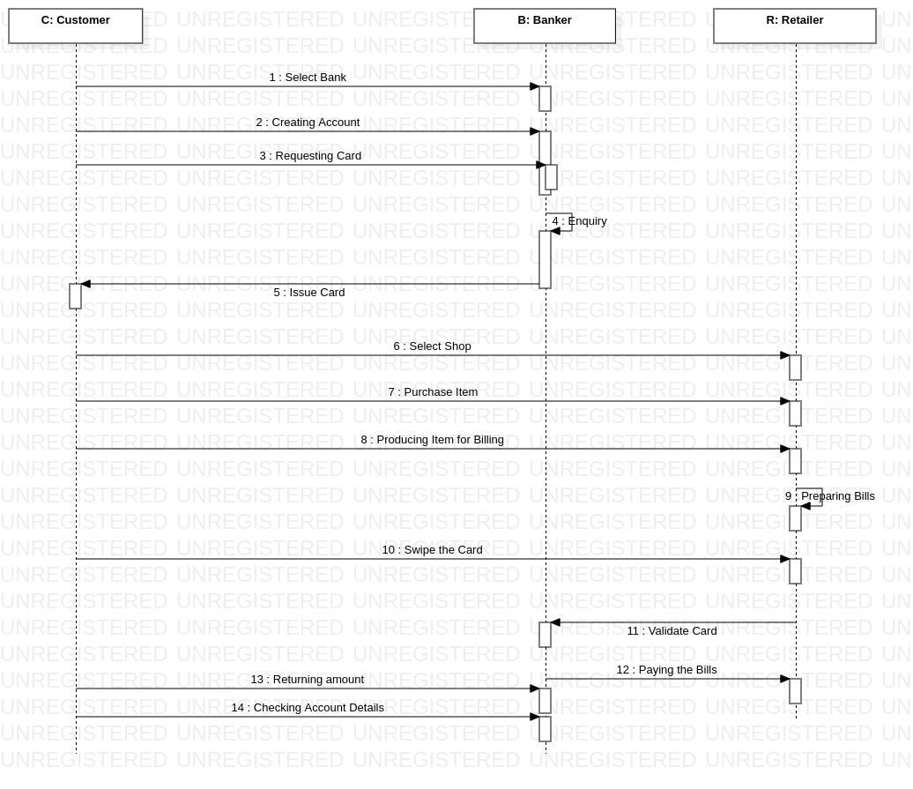

**DOCUMENTATION OF COLLABARATION DIAGRAM**

* The Customer,Banker and Retailer are all shown in the sequence
* The customer creates the bank account and requests for the credit card from the bank
* After customer purchase any item retailer will be validating the customers credit card with bank account and the payment would be successful.

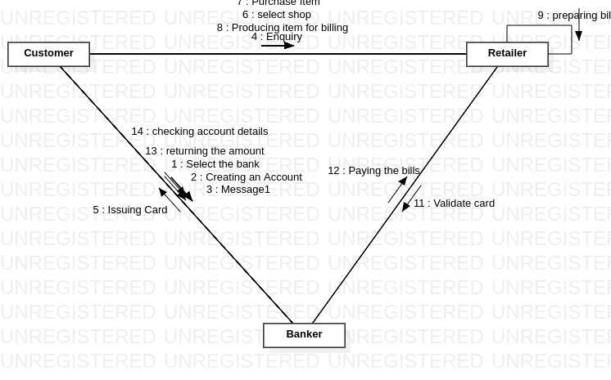

**DOCUMENTATION OF STATE CHART DIAGRAM**

* The states of the credit card processing are shown in the state chart diagram
* The customer state represents what are operations done by the customer like creating account, requesting credit card etc.
* The creating account state allows the customer to create the account in the bank.In this state all the customer details will be taken.
* In requesting credit card state the customer requests to issue the credit card from the bank.
* Based on the customer details the enquiry from bank state will be checking all the customer details.
* If all the customer details are valid the Issuing card state will be issuing the card for the customer if not the bank will abort the process.

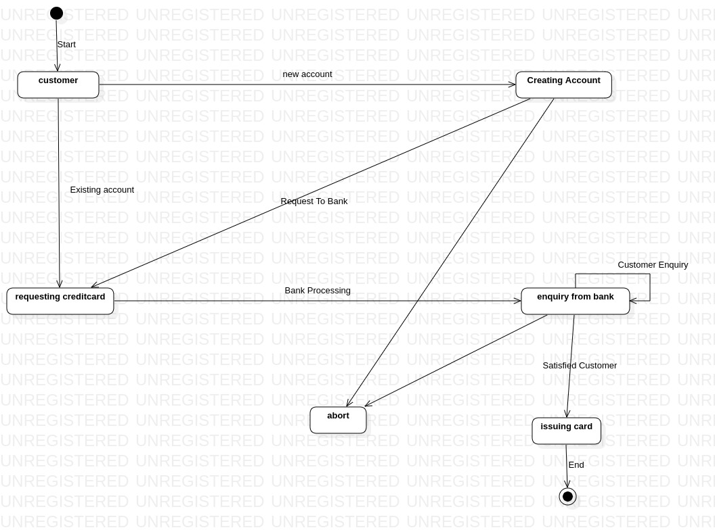

**DOCUMENTATION OF ACTIVITY DIAGRAM**

* The activities in the credit card processing system are Enter the credit card details,Submiting the details,Asking for confirmation,Payment successfull and update database.
* In enter credit card details activity the customer will be entering the credit card details and submitting them, if the details are correct then it will be displaying all the details or else it will be asked to enter all the details again.
* Once the correct details are entered and confirmed then the payment would be successful and it is updated in the database.

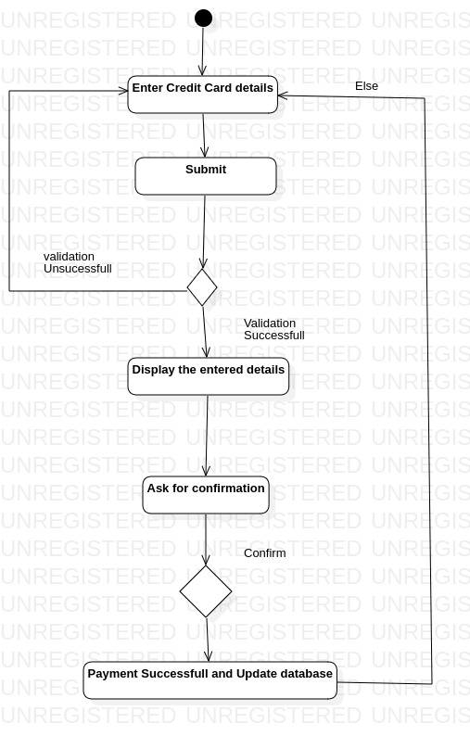

**DOCUMENTATION OF COMPONENT DIAGRAM**

* The components in the credit card processing system are Database server,The web server and the client machine.
* The client machine will be consisting all the credit card details the user is entering in the web browser.
* The web server and the database server are depending on the details entered by the client machine.

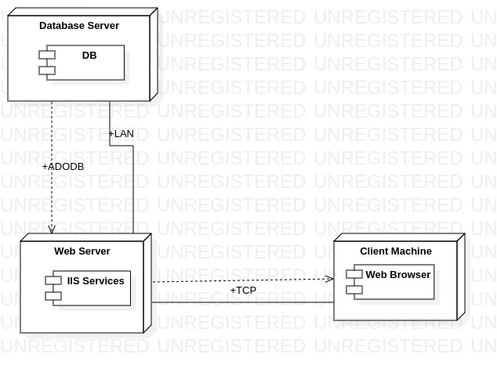

**DOCUMENTATION OF DEPLOYMENT DIAGRAM**

* The device node is the data base server and application server and execution environment node are web server.
* Inside the application server all the details entered by the user in the web server are processed and validated based on the details present in the database server.

